Code Analysis – Challenge Solution: Wonderland 4
By: Tehila Chananayev

Introduction

This challenge presents a piece of assembly code where the user enters a number, and the program checks whether the input is correct. Our goal is to reverse engineer the logic, identify the test conditions, and find the correct number that passes verification with the exercise requirement (no cracking in any way. No code changes, no registers, no memory...)

Code Structure
The beginning of the code begins a while (true) loop using:
test 1, 1
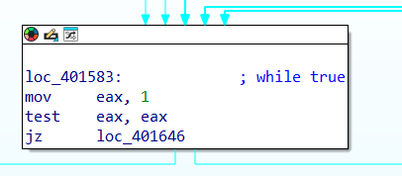
Since test 1, 1 always returns a non-zero result (sets ZF = 0), the condition is always true, creating an infinite loop — a classic way of implementing while (true) in Assembly.

After receiving the following code, it receives a numeric value from the user using the scenf function and also using %du. This can be seen
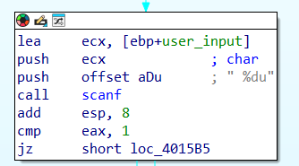

Core Logic
The following code compares two values using the strncmp function. The value stored in the ecx register contains the memory address ebp + str, which is 0019FEF8, and it holds the string "Good luck!!". On the other hand, the edx register contains the user input.
The comparison checks if the string located at ecx matches the input stored in edx. If the comparison is successful, the program proceeds as expected.
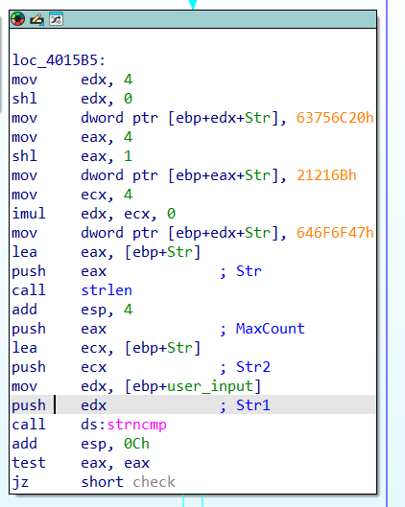

I tried to input the address where the string is stored, specifically EBP + STR, to compare the exact same string from the same memory location. The initial check passed successfully. However, there was another check that caused an issue.
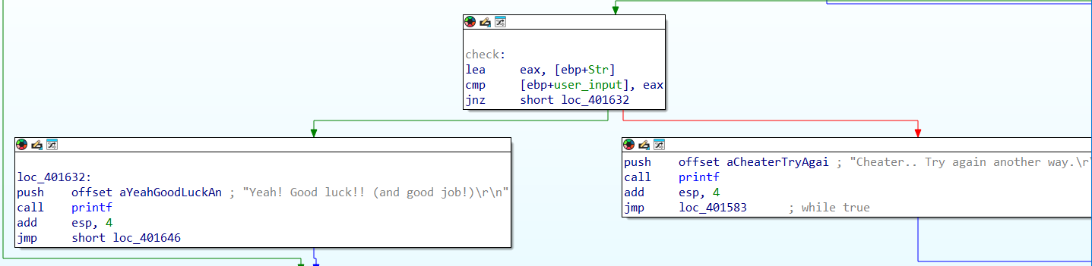

This additional check verifies that the strings are not located at the same memory address. As a result, I had to search for the same string elsewhere in memory. Eventually, I found it at a different address, which allowed the check to pass.

Therefore, I went to memory using Alt + B, where I entered the string "Good luck!!". I discovered that the string appeared within another string, "Yeah! Good luck!! (and good job!)\r\n", which contained the substring I needed. I then extracted just the "Good luck!!" part, which was located at the address 40473E in hexadecimal, and 4212542 in decimal. This allowed me to pass the check, as it confirmed that the same string existed at different memory locations.

